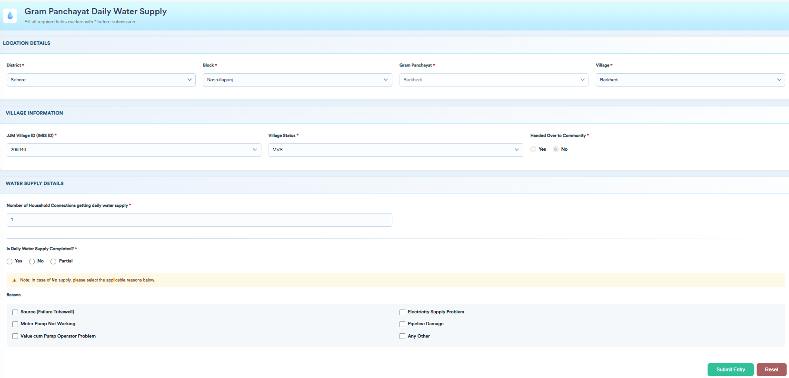
Household Connections Established (स्थापित घरेलू नल कनेक्शन)
Water Supply Date जल प्रदाय दिनांक (Date Picker)
Water Supply Status जल प्रदाय की स्थिति
Yes हाँ | No नहीं | Partial आंशिक – Connections Supplied Water जल प्रदाय कनेक्शन की संख्या [] [Remarks]
- Source (Tubewell Failure)
- Source (OHT Not Filled By MVS Contractor)
- Motor Pump Not Working
- Valve cum Pump Operator Problem
- Electricity Supply Problem
- Pipeline Damage
- Any Other (Remarks)

